**Group 6 - Assignment 2**

**Names of group members:**

Faiza Quadri, Rebecca Lee, Yichen Pan, Zixi Lei, Briana Ramirez, Stephen Rhee

1. Collected 5506 non-duplicate tweets on the Pennsylvania Senate race in tweets.csv. The keywords used to search for tweets were “PA + Senate”. Similar words for key issues and candidate names were replaced using find_replace_tweets.csv into tweets_replaced.csv.
2. The **key issues** mentioned most often by the public were:

|  |  |
| --- | --- |
| **Issue** (similar words used in find_and_replace.py) | **Frequency** |
| **Health** (medical, stroke, records, release, health, unfit, fit) | 2373 |
| **School District taxes** (school, district, tax, taxes) | 2162 |
| **Character** (fake, lying, dangerous, respected, lies, character) | 1473 |
| **Women's rights** (women, codify, roe, abortion, rights, female) | 998 |

1. **Lift and sentiment analysis** on each candidate and issue:

|  |  |  |
| --- | --- | --- |
| **Candidate & Issue** | **Lift** | **Sentiment Score (if lift > 1)** |
| **Health & Fetterman** | 1.462324968 | 23.46%positive, 3.37%negative --> Positive |
| **School District taxes & Fetterman** | 1.392414665 | 49.68%positive, 3.37%negative --> Positive |
| **Character & Fetterman** | 1.514317635 | 22.32% positive, 21.93% negative --> Positive |
| **Women’s rights & Fetterman** | 1.399555253 | 49.68% positive, 0.34% negative --> Positive |
| **Health & Oz** | 2.365024131 | 26.31%positive, 3.8% negative--> Positive |
| **School District taxes & Oz** | 0.126974354 | N/A bc lift is less than 1 |
| **Character & Oz** | 2.277559905 | 7.16% positive, 61.04% negative --> Negative |
| **Women’s Rights & Oz** | 2.421508248 | 65.81% positive, 1.83% negative --> Positive |

1. Attributes and candidates on an MDS plot

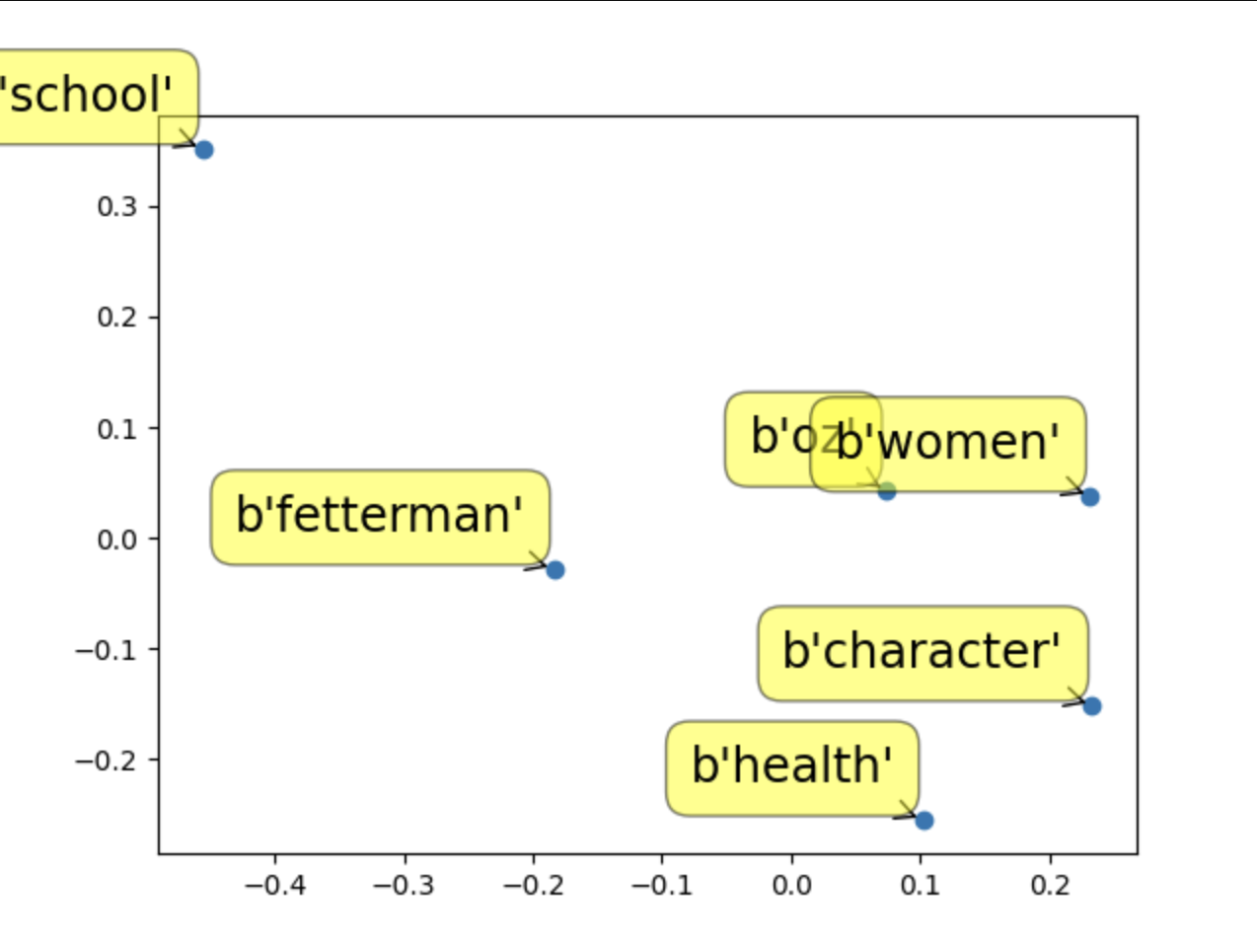

1. **Lifts** and **sentiments** regarding the candidates in large versus small cities/towns in Pennsylvania

Lift Analysis:

|  |  |  |
| --- | --- | --- |
|  | John Fetterman | Mehmet Oz |
| Big_city PA | 0.8131 | 1.0738 |
| Small_town PA | 0.7428 | 0.9526 |

Sentiment Analysis:

|  |  |  |
| --- | --- | --- |
|  | John Fetterman | Mehmet Oz |
| Big_city PA | N/A bc lift is less than 1 | 10.4%positive, 10.2%negative --> positive |
| Small_town PA | N/A bc lift is less than 1 | N/A bc lift is less than 1 |

1. Advice:

Summary:

* From the MDS plot, Oz seems to be closer to “women”, “character” and “health” than Fetterman is. These issues are more strongly associated with Oz than Fetterman.
* From the location analysis, both Fetterman and Oz have relatively low lift values (less than 1) at small towns. For big cities, Oz has a higher lift value (greater than 1) and a positive sentiment score. Overall Oz is more mentioned in both big cities and small towns.

For Fetterman:

* Fetterman is located around the center of the MDS map.
* **John Fetterman should continue emphasizing what he has been about “school, district, taxes”** as this is his strongpoint (49.68% positive sentiment) compared to Oz who does not even have an association with this issue.
* Although Fetterman’s sentiments are all positive, Oz has stronger associations with the issues. So **Fetterman should continue the messaging but increase the reach & amount in order to gain stronger association with the issues with more voters.**
* When comparing small and large cities, Fetterman has lift values of less than one, meaning there is no association between them. One explanation could be that voters in both small towns and big cities are not familiar with Fetterman. So **Fetterman should increase his presence on platforms and find ways to get his name out to the voters.**

For Oz:

* From the MDS plot, we found Oz and women’s rights have a relatively high similarity among those popular topics. This might because the impressions of the general public always associate candidate Oz with female-related issues, such as abortion. Oz and women’s rights also have high lift values, which means strong correlation, and a positive sentiment score. **We recommend that Oz keeps his current campaign on women’s rights since it proves to be effective according to our analysis. The same thing applies to health-related issues since “Oz and Health” has a high lift value and strong positive association.**
* From the sentiment analysis, Oz and the issue ‘’character” - defined as, fake, lying, dangerous, respected, lies, character – are strongly associated, but *negative sentiment.* **Oz should work on changing this view, promoting himself as a trustworthy candidate. This should be Oz’s primary focus, as it has both a high lift and negative sentiment.**
* From the lift value analysis, Oz and the issue “school and district” are seldom mentioned together since the lift value is less than 1. **We recommend him campaign more for school, district, and taxes related issues. This will attract more voters that have families and children.**
* For the location analysis, Oz has a low lift value in small towns and a relatively higher lift value in big cities. **We recommend that Oz campaign more in small towns to gain this section of voters.**